**Views:**

In SQL, a view is a virtual table derived from the result of a SELECT query. It doesn't store the data itself but provides a way to represent the result of a query as if it were a table. Views are used to simplify complex queries, encapsulate logic, and provide a layer of security by controlling access to certain columns or rows.

**Materialized Views:**

Some databases support materialized views, which are physical copies of the result set stored for faster access. Materialized views need to be refreshed periodically to reflect changes in the underlying data.

**Example:**

**Creation of a view:**

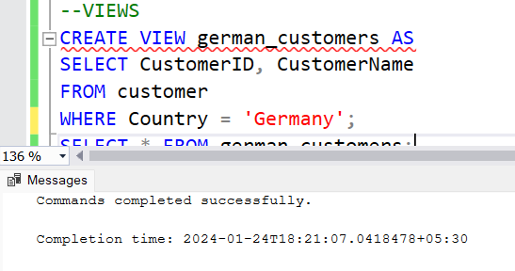

**Retrieving data of a view:**

